PROGRESS REPORT KELOMPOK 3

HelpDesk

Selasa, 19 Febuari 2019

Anggota :

Muhamad Ilham Habibie

M. Iqbal Aula Rahman

Proggress :

1. Transaksi masih dalam status on progress.
2. Login, Register, Forget Password belum terbentuk.
3. Acivity Diagram belum terevisi dari kelompok sebelumnya

|  |  |  |  |  |  |  |
| --- | --- | --- | --- | --- | --- | --- |
| **Nama** | **Modul** | | | | | |
| **Province** | **Regency** | **District** | **Village** | **Role** | **Religion** |
| Ilham | Done |  |  |  |  |  |
| Iqbal |  | Done | Done | Done | Done | Done |
|  |  |  |  |  |  |  |
| **Nama** | **Modul** | | | | | |
| **Priority** | **Category** | **Ticket** | **Ticket Progress** | **Customer** | **Staff** |
| Ilham | Done | Done | Done | On Progress |  |  |
| Iqbal |  |  |  | On Progress | Done | Done |

1. ERD

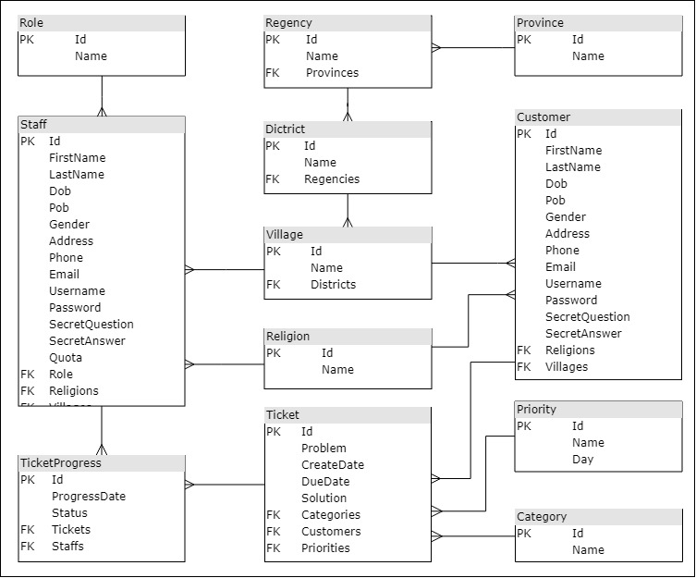

1. Use Case Diagram

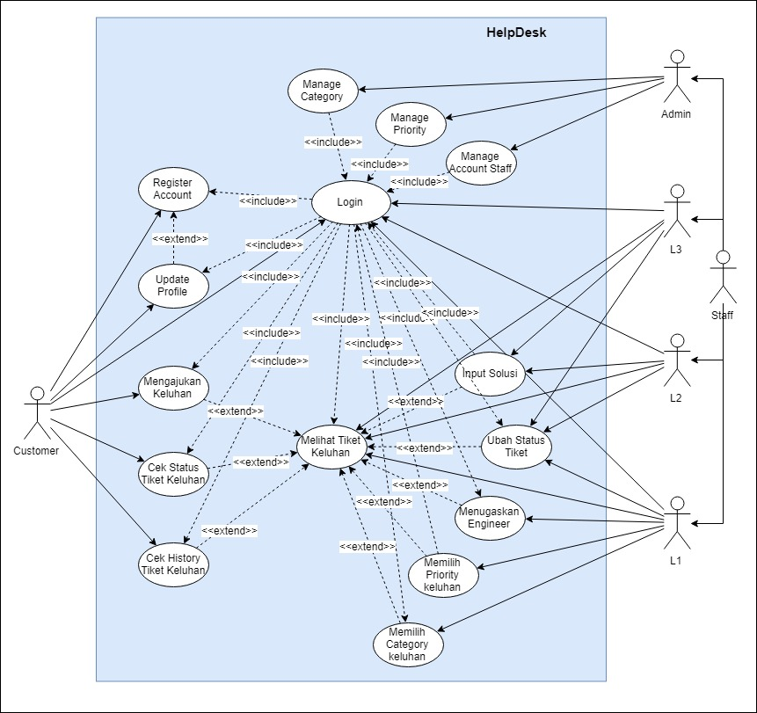

1. Class Diagram

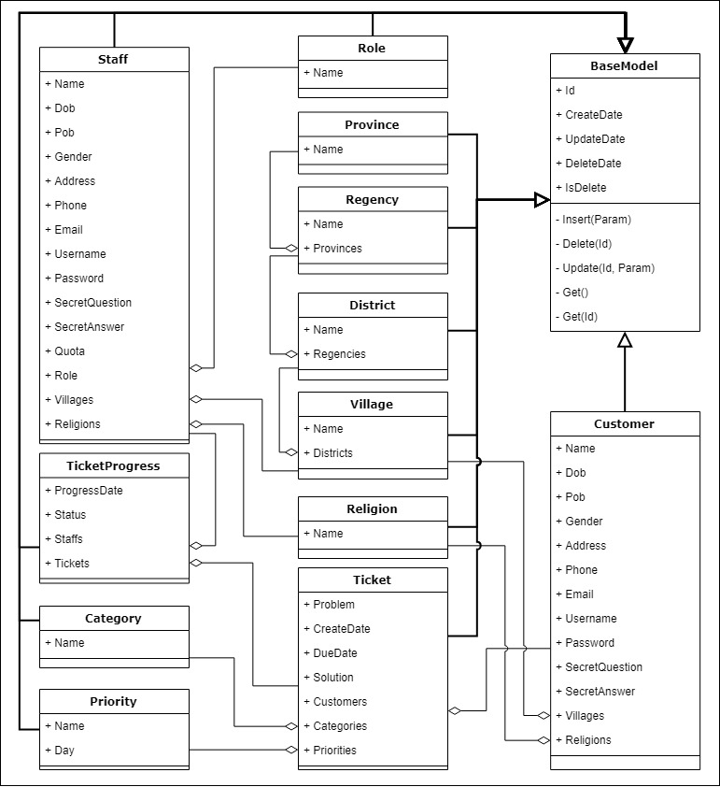

1. Activity Diagram